ShopHub

___________________________________________

Model Testing

___________________________________________

Student Name: Nischal Aryal

Student ID: 77261069

Module Name: Production Project

# Accuracy of LSTM model

The training accuracy of an LSTM model with Word2Vec embedding for customer review sentiment analysis refers to the percentage of correctly classified customer reviews in the training dataset. This approach involves preprocessing the data, applying Word2Vec embeddings to represent words as numerical vectors, constructing the LSTM model architecture, training the model using backpropagation and gradient descent, and evaluating its performance on the training set. While training accuracy provides insight into the model's performance on the training data, it's important to also assess its generalization capabilities on a separate test dataset to ensure reliable sentiment analysis on new, unseen customer reviews.

The testing accuracy of an LSTM model with Word2Vec embedding for customer review sentiment analysis refers to the accuracy achieved when evaluating the model's performance on a distinct test dataset. It indicates the percentage of customer reviews correctly classified by the model in the test set. Once the model is trained using the training data, it is tested on a separate dataset containing customer reviews with known sentiment labels. This evaluation measures the model's ability to generalize and accurately predict sentiment in real-world scenarios, providing valuable insights into its performance beyond the training dataset.

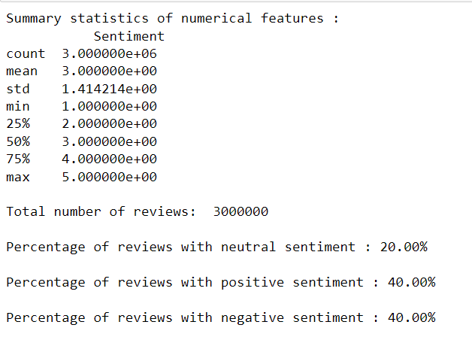

Figure : Data distribution of the dataset

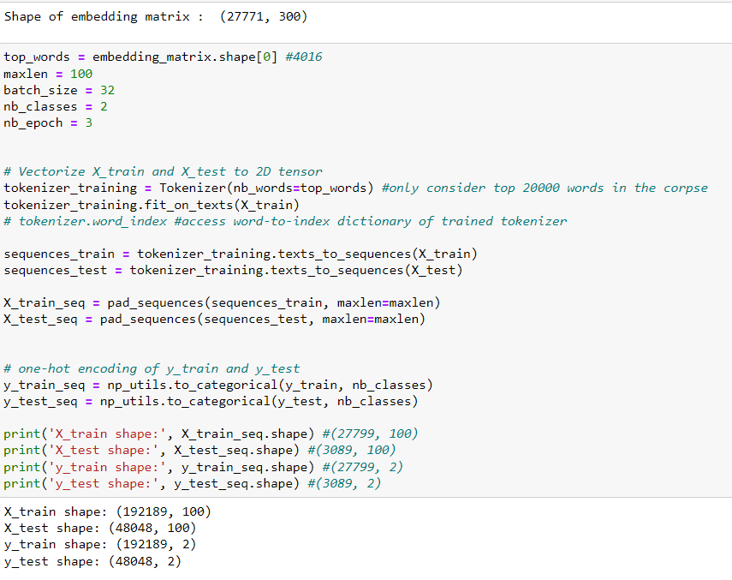

Figure : Statistical data of our training and testing data and embedding matrix

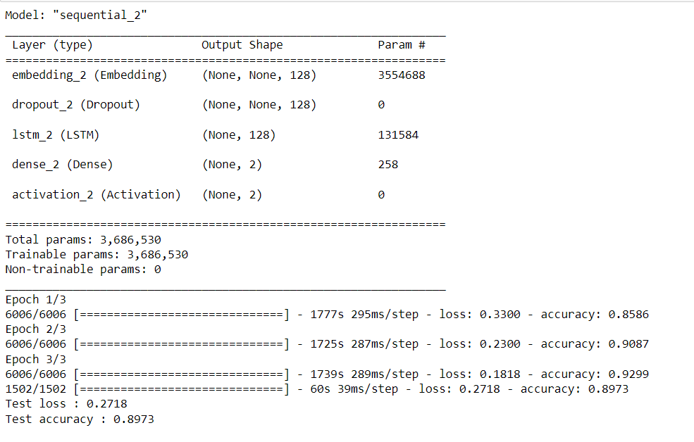

Figure : Testing Accuracy (89.73%) of the LSTM model

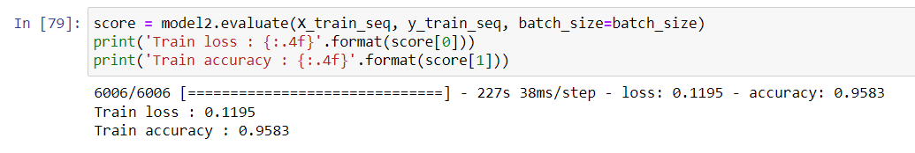

Figure : Training Accuracy (95.83%) of the trained LSTM model

# Saving the trained model and testing

Once the LSTM model with Word2Vec embedding for customer review sentiment analysis is trained, it can be saved along with the tokenizer for future use in making predictions on new data. Saving the trained model involves storing its architecture, weights, and optimizer state, allowing it to be reloaded later without the need for retraining. The tokenizer, which was used for preprocessing the text data, is also saved to ensure consistent encoding of new input. To use the saved model for further prediction, the model and tokenizer are loaded back into memory. The loaded model can then be used to predict sentiment on new customer reviews by passing the preprocessed text through the loaded tokenizer and feeding it to the model for inference. This process enables the model to make accurate sentiment predictions on unseen data without the need to repeat the training procedure.

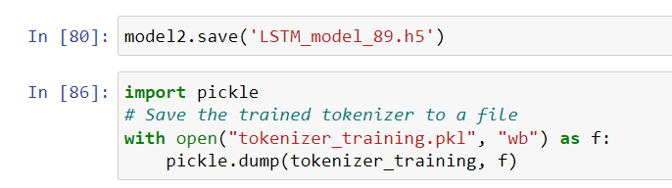

Figure : Saving the trained model, tokenizer

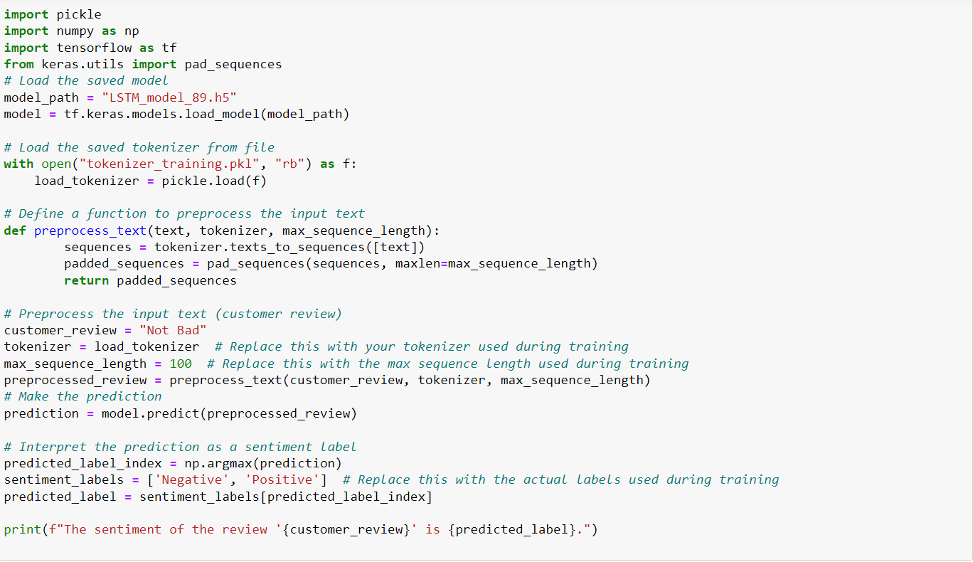

Figure : Loading the saved model, tokenizer to make the predictions

## Testing the reviews

We expect the model to predict a “**Not Bad**” review as “**Positive**” and the prediction is as expected.

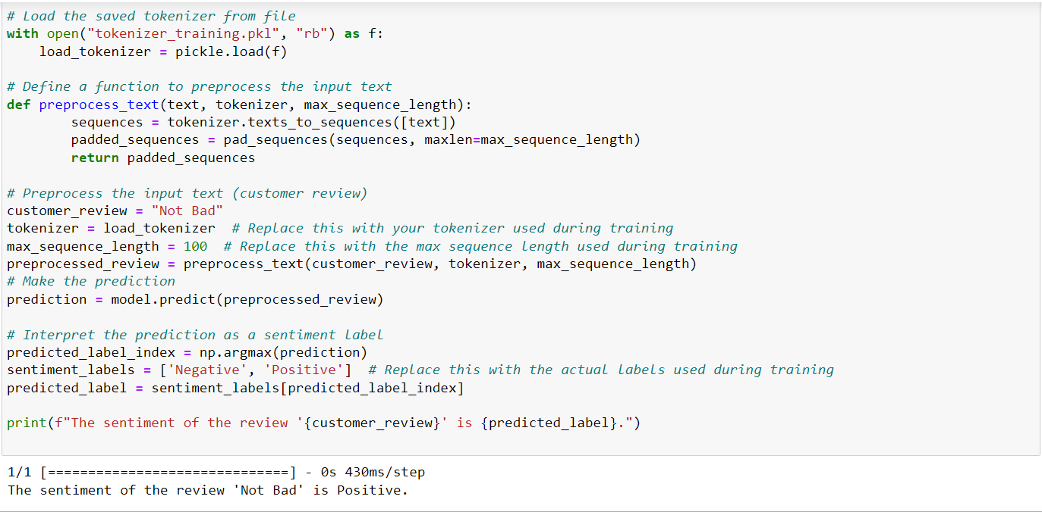

Figure : Testing for "Not Bad" review

We expect the model to predict a “**It didn’t work as advertised**” review as “**Negative**” and the prediction is as expected.

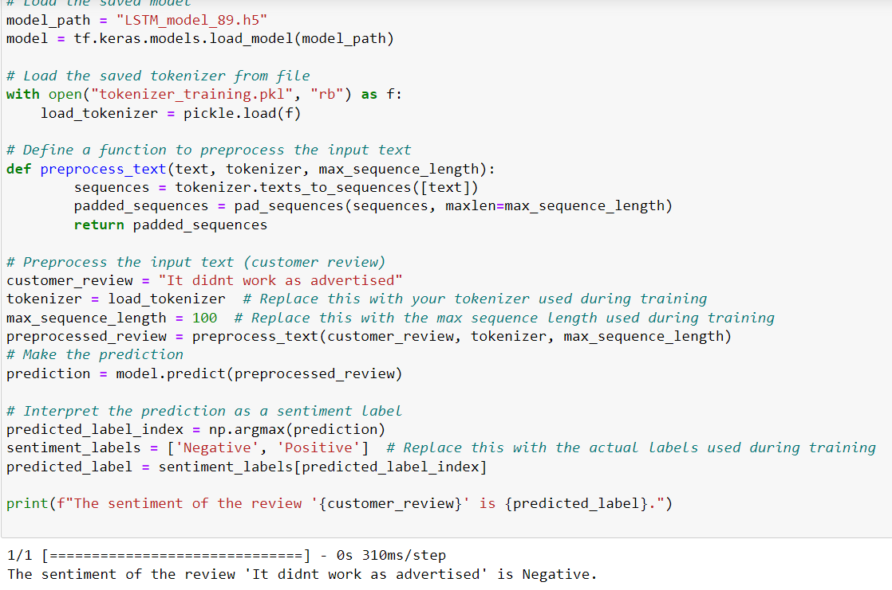

Our model is predicting sentiment as expected as per the review so we can conclude that our model works fine most of the time for real-time review data of the customers.